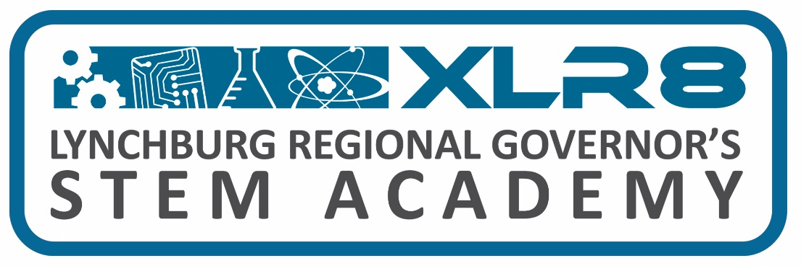

XLR8 STEM Academy Board Meetings Board Members
- Location: TBD Amherst: Chris Terry
- Time: 1:00 pm Appomattox: Wyatt Torrence
- Dates: Bedford: Marcus Hill
- Tuesday, August 16th, 2022 Campbell: Mark Epperson
- Tuesday, November 15th, 2022 Lynchburg: TBD
- Tuesday, January 24th, 2023
- Tuesday, March 21st, 2023
- Tuesday, May 23rd, 2023
- Wednesday, June 21st, 2023 (combined meeting @ 11:30 am)
- Tuesday, August 8th, 2023

XLR8 STEM Academy Partnership Team Meetings
Location: CVCC, AREVA Technology Building, Room 6201
Time: see below
Dates:
Wednesday, October 26th, 2022 (meeting @ 1:00 pm)
Wednesday, June 21st, 2023 (combined meeting @ 11:30 am)

