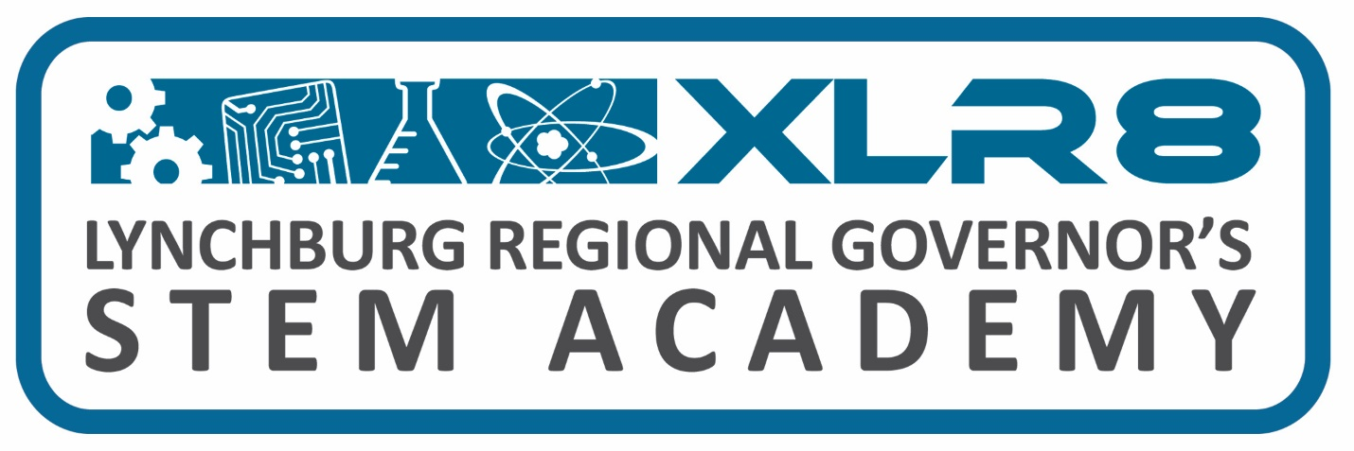
XLR8 STEM Academy Board Meeting & Partnership Team Meeting Schedule 2023-2024

XLR8 STEM Academy Board Meeting Schedule Board Members
Location: ZOOM Amherst: Eric Orasi
Time: 11:00 am Appomattox: Wyatt Torrence
Bedford: Marcus Hill
Dates: Campbell: Mark Epperson
Monday, July 10th, 2023 Lynchburg: Sharon Carter
Tuesday, September 12th, 2023
Tuesday, November 14th, 2023
Tuesday, January 23rd, 2024
Tuesday, March 19th, 2024
Tuesday, May 21st, 2024
Wednesday, June 12th, 2024 (joint meeting)-11:30 am
Tuesday, August 13th, 2024

XLR8 STEM Academy Partnership Team Meeting Schedule
Location, CVCC, Framatome Building, Room 6201
Time: see below
Dates:
Wednesday, October 25th, 2023 – 11:00 am
Wednesday, June 12th, 2024 (joint meeting) -11:30 am

